**Experiment 10:**

Write a program to print the address of a variable and enter a long loop using while(1)

1. Start three to four processes of the same program and observe the printed address values

C program :

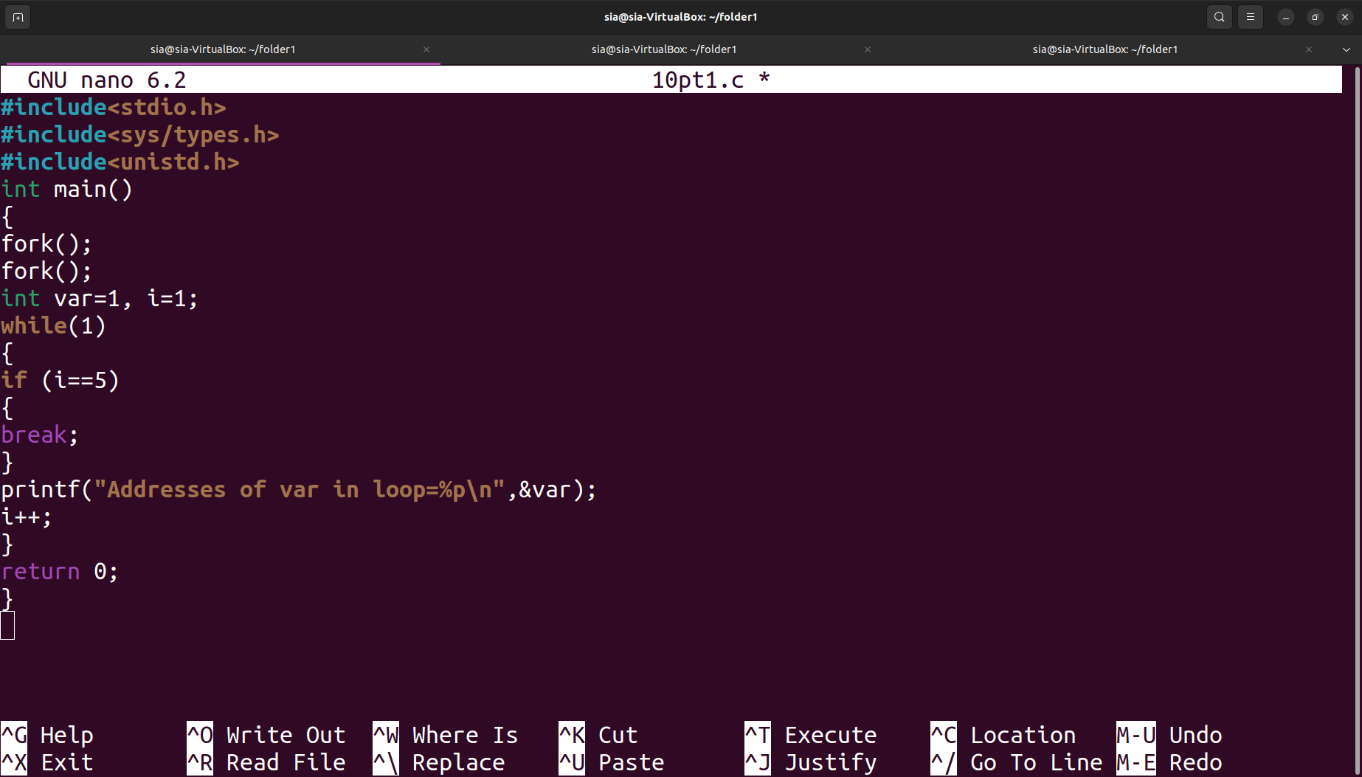

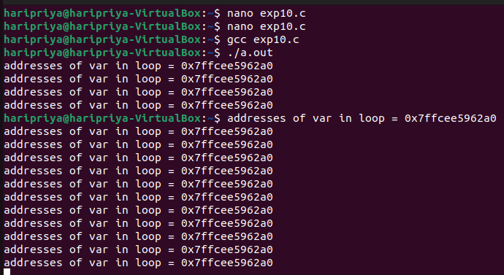Output:

## 

1. Show how two processes which are members of the relationship parent child are concurrent from execution point of view , initially the child is copy of the parent , but every process has its own data

C program:

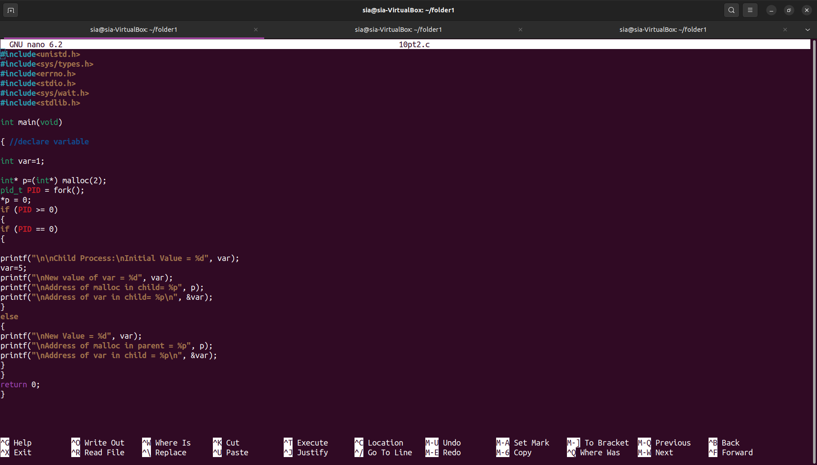

Output:

